Syeda Reeha Quasar

14114802719

4C7

Aim

Write the queries for implementing the following functions: MAX(), MIN(), AVG(), COUNT() and other logical pattern matching operations.

Experiment - 6

DATABASE MANAGEMENT SYSTEMS LAB

# **EXPERIMENT – 6**

## **Aim:**

Write the queries for implementing the following functions: MAX(), MIN(), AVG(), COUNT() and other logical pattern matching operations.

## **Tools Used:**

MariaDB

## **Procedure/ Queries:**

1. List the names of all clients having 'a' as the second letter in their names.

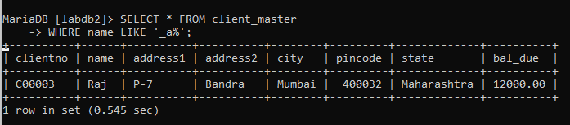

1. List the client who stay in the city whose first letter is 'M.

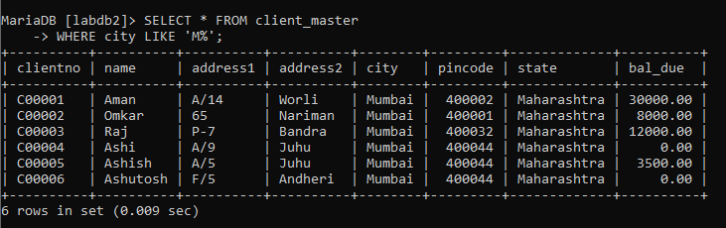

1. List all clients who stay in 'Manglore’ or ‘Banglore'

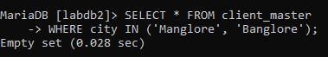

1. List all the clients whose bal due=8,000.

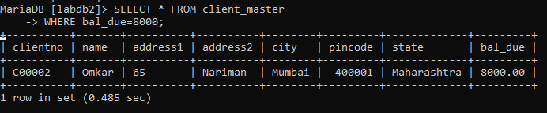

1. List all the information frome sales order for orders placed in the month of June October.

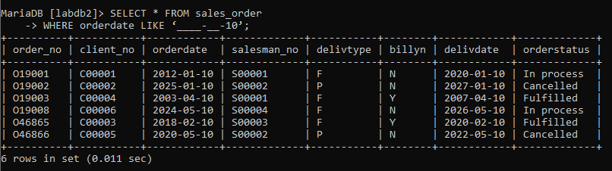

1. List the order information for the client number 'C00001' and ' C00002
2. List the products who selling price is greater than 500 and less than or equal to 750.

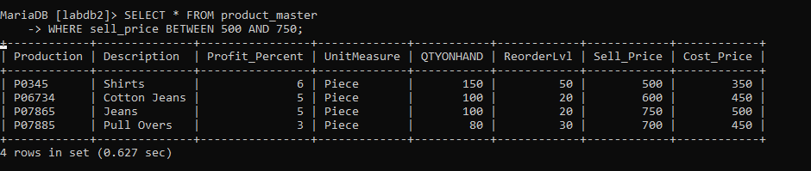

1. List products who's selling price is more than 500. Calculate a new Selling Price as original selling price multiplied by 0.15.

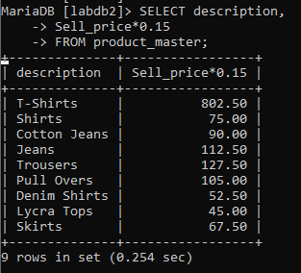

1. Rename the new column in the output of above query as new_price.

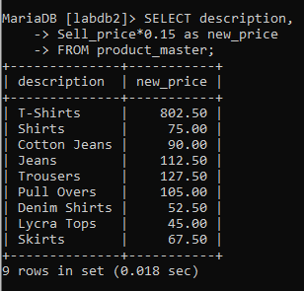

1. List the name city of clients who are not in the state of Maharashtra'.

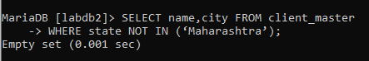

1. Count the total number of orders.

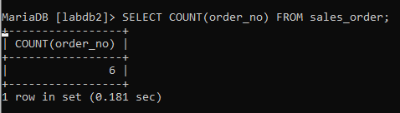

1. Calculate the average price of all the products.

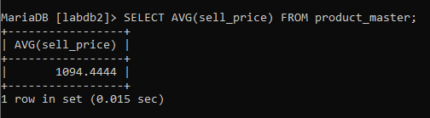

1. Determine the maximum and minimum product prices. Rename the output as max price and min_price respectively.

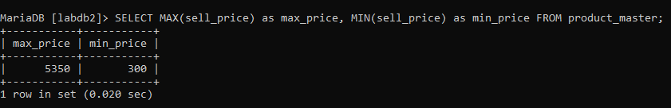

1. Count the number of products having price less than or equal to 500
2. List the products whose qtyonhand is less than 3 order level.

SELECT * FROM client_master  
WHERE name LIKE '_a%';

SELECT * FROM client_master  
WHERE city LIKE 'M%';

SELECT * FROM client_master   
WHERE city IN ('Manglore', 'Banglore');

SELECT * FROM client_master   
WHERE bal_due=8000;

SELECT * FROM sales_order   
WHERE orderdate LIKE ‘____-__-10’;

SELECT * FROM sales_order_details   
WHERE clientno IN ('C00001', 'C00002');

____________________________________________

SELECT * FROM client_master   
WHERE city IN ('Manglore', 'Banglore');

SELECT * FROM product_master   
WHERE sell_price BETWEEN 500 AND 750;

SELECT * FROM product_master   
WHERE sell_price BETWEEN 500 AND 750;

SELECT description,

Sell_price*0.15

FROM product_master;

SELECT description,

Sell_price*0.15 as new_price

FROM product_master;

SELECT name,city FROM client_master   
WHERE state NOT IN (‘Maharashtra’);

SELECT COUNT(order_no) FROM sales_order;

SELECT AVG(sell_price) FROM product_master;

SELECT MAX(sell_price) as max_price, MIN(sell_price) as min_price FROM product_master;

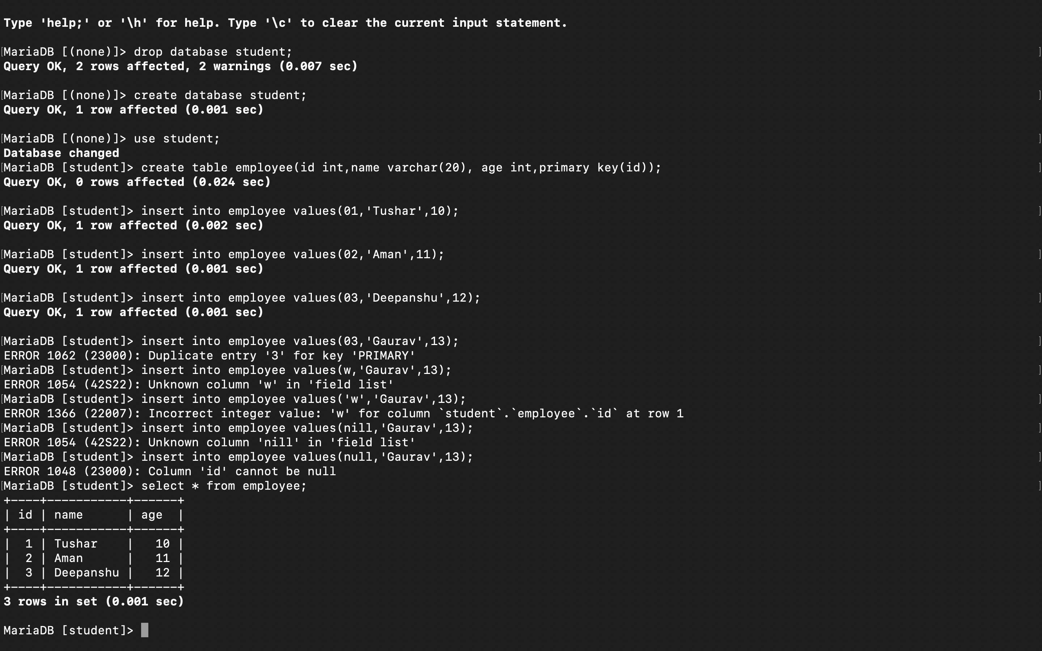

* 1. SELECT COUNT(*) AS `Count` FROM Client_master;

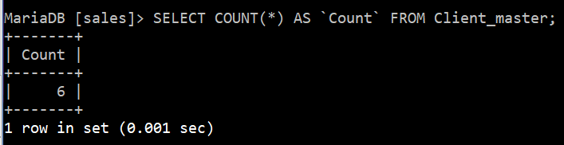

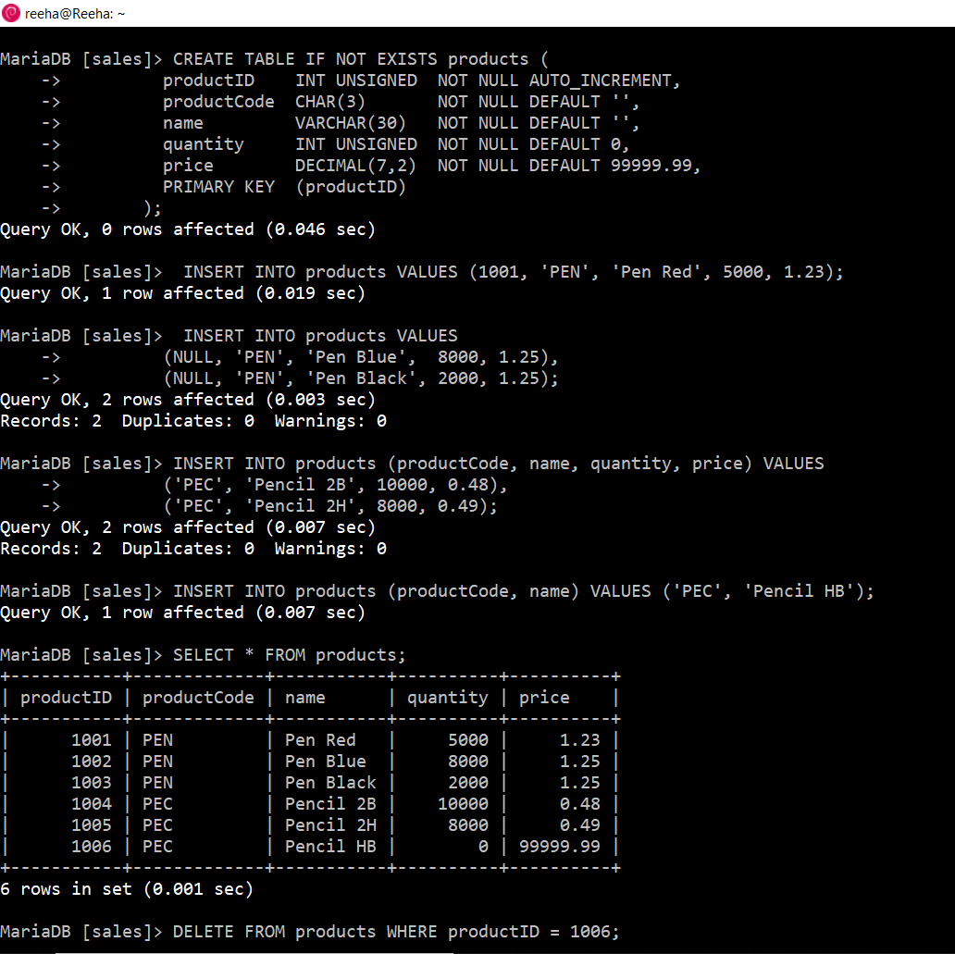

SELECT COUNT(*) AS `Count` FROM products; SELECT COUNT(*) AS `Count` FROM products; 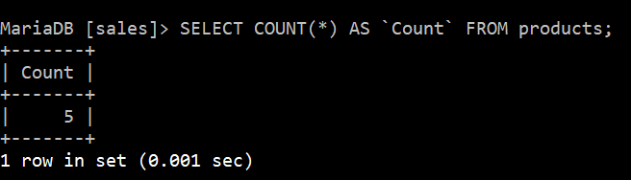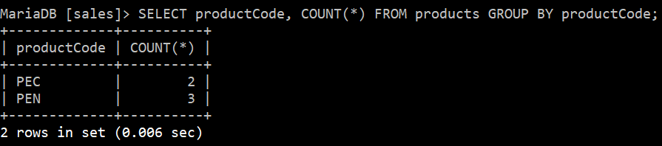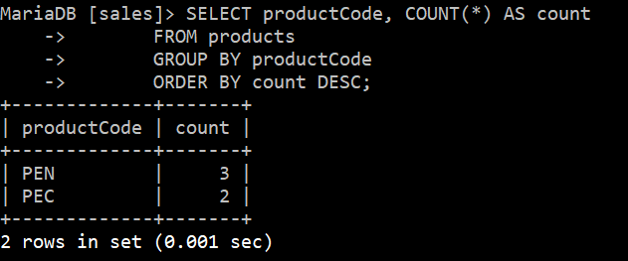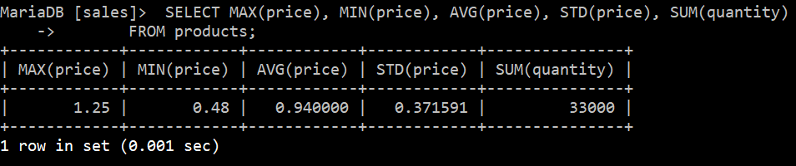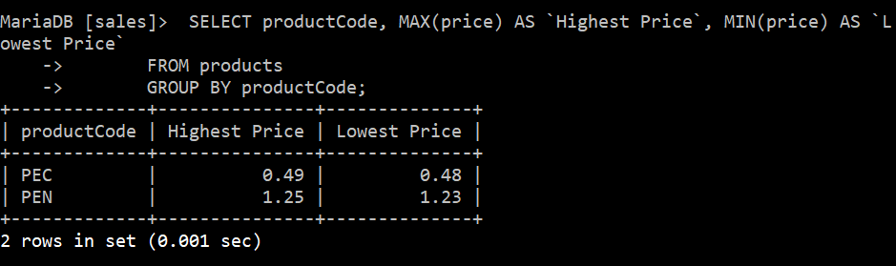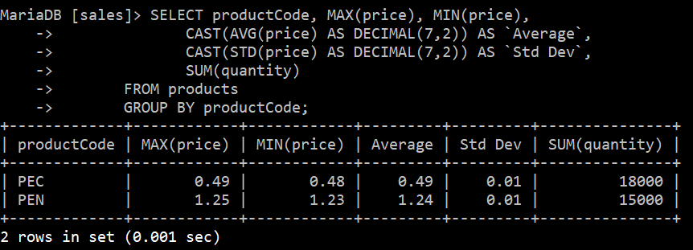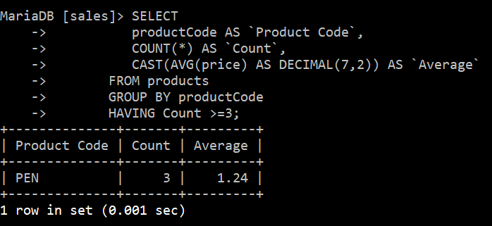

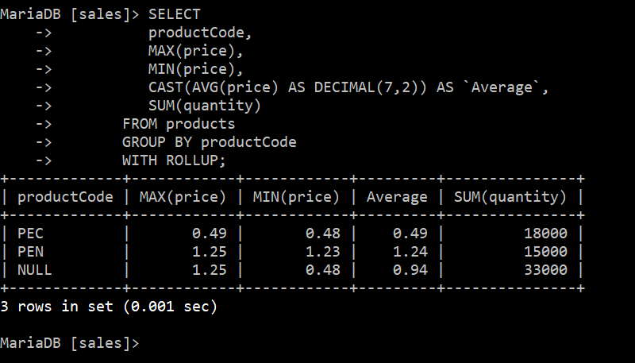

# VIVA VOCE QUESTIONS

## Q.1 What are pattern matching operation?

**Ans**

SQL pattern matching allows you to search for patterns in data if you don't know the exact word or phrase you are seeking. This kind of SQL query uses wild card characters to match a pattern rather than specifying it exactly.

## Q.2 What are different variants of like command?

**Ans.**

|  |  |
| --- | --- |
| LIKE Operator | DESCRIPTION |
| WHERE CustomerName LIKE ‘a%’ | Finds any value that starts with “a” |
| WHERE CustomerName LIKE ‘%a’ | Finds any value that ends with “a” |
| WHERE CustomerName LIKE ‘%or%’ | Finds any value that has “or” in any position |
| WHERE CustomerName LIKE ‘_r%’ | Finds any value that has “r” in the second position. |
| WHERE CustomerName LIKE ‘a_%_%’ | Finds any value that starts with “a” and are at least 3 characters in length. |
| WHERE ContactName LIKE ‘a%o’ | Finds any value that starts with “a” and ends with “o”. |

## Q.3 What are different Logical operations?

**Ans.**

|  |  |
| --- | --- |
| **OPERATOR** | **DESCRIPTION** |
| ALL | True if all of the subquery values meet the condition |
| AND | True if all the conditions separated by AND is true. |
| ANY | True if any of the subquery meets the condition. |
| BETWEEN | True if operand is within the range of comparisons. |
| EXISTS | True if the subquery returns one or more records. |
| IN | True if the operand is equal to one of a list of expressions. |
| NOT | Displays a record if the condition(s) is NOT TRUE |
| OR | True if any of the conditions separated by OR is true. |

## Q.4 What is difference between IN and BETWEEN command?

**Ans.**

The IN command allows you to specify multiple values in a WHERE clause. it is a shorthand for multiple OR conditions.

Whereas BETWEEN command select values within a given range the values can be numbers, text or dates. The BETWEEN operator is inclusive: begin an end value are included.